January 7, 2015

Clem Herman
Editor, International Journal of Gender, Science and Technology
Dept of Computing and Communications
The Open University
Walton Hall
Milton Keynes, MK7 6AA, UK

Dear Dr. Herman,
I’m pleased to submit our manuscript entitled “An Exploration of Women Academic Scientists’
Experiences with Gender in North Africa and the United States” for your consideration.

This qualitative study, conducted in conjunction with a research partnership held in Morocco in 2013, sought to learn about women’s experiences with gender in academic sciences in three countries in North Africa and in the United States. As you will see, we found that women scientists’ experiences were profoundly different in the two regions, with North African women experiencing greater gender equity in the workplace compared with Americans, but far less equity in the home.

My colleague and I appreciate your consideration of our research. We believe this work is unique in highlighting the experiences of women academic scientists in North Africa, where conditions are better in many ways than stereotypes might suggest. We hope you find this manuscript to be good fit for the International Journal of Gender, Science and Technology

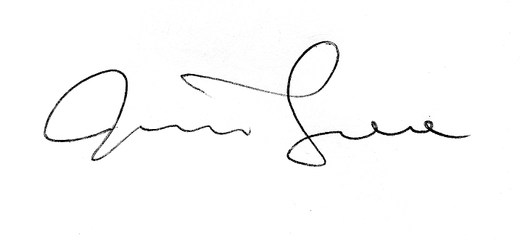
Sincerely,

Jessica Greene, Ph.D.
Professor
Director of Research

