Figures

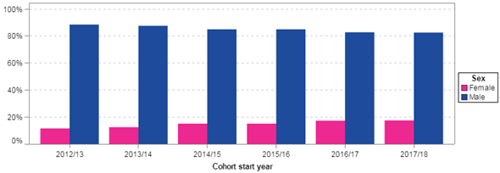
Figure 1: Proportion of women and men enrolled on single honours Q62

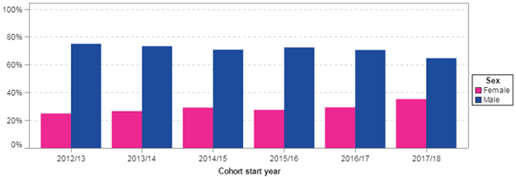

Figure 2: Proportion of women and men enrolled on joint honours Q67

 | BSc Computing & IT (Q62) | BSc Computing & IT & another subject (Q67) | Total
Women  (n) | 36.3%  (n=66) | 22.6%  (n=38) | 168
Men  (n) | 69.4%  (n=59) | 8.2%  (n=7) | 85
Total (n) | 49.4%  (n=125) | 17.8%  (n=45) | 253

Table 1 Proportion of participants with different degree intentions by gender

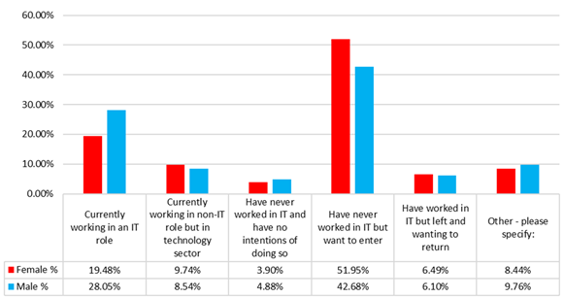

Figure 3 Experience of working in the IT/Tech sector by gender

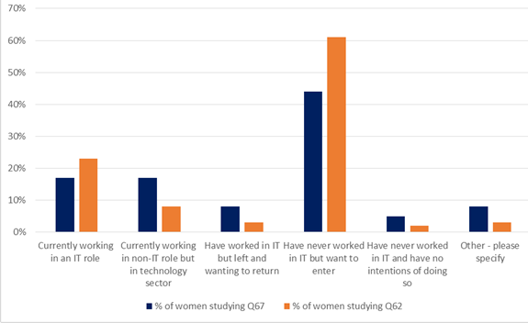

Figure 4 Experience of working in the IT/Tech sector for women by degree intention
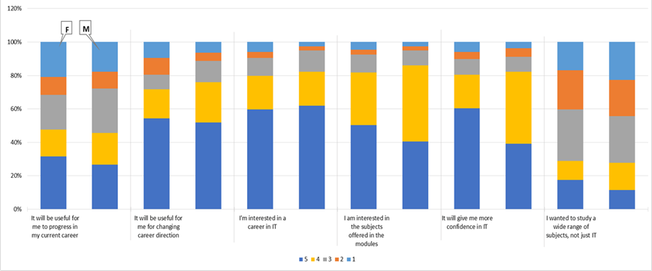

Figure 5 Reasons for choosing the degree registered on

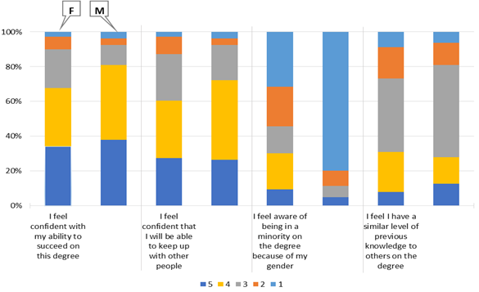

Figure 6 Feelings about studying the degree registered on

